Counseling, Mediation, & Educational Center, Inc.
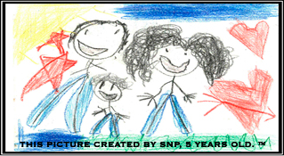
Our mission is to provide counseling, mediation, and educational services to assist children and their families who are experiencing separation due to incarceration, juvenile delinquency, divorce, and various other family separations.

Referral for Services

Date of Referral______________________

Agency Completing Referral _________________Individual Completing Referral:_________________________

Contact Phone of Individual/Agency Completing Referral _________________________

CLIENT INFORMATION:
Name________________________________________________DOB_______________
IF client is under 18 please provide Parent/Guardian Name____________________________________________
Work Phone: ______________________________Cell Phone: ___________________________
Address__________________________________________________________________
Race___________ Age: ________________ Gender:___________________
Payment by referral source: _________Yes ________NO________
Insurance Type: ______________________Private ______or Medicaid _____
Medicaid/Insurance Number ________________________________
Reason for Referral __________________________________________________________________________________________________________________________________________________________________________________________
I am referring this client for:
Stepping Stones Program (COIP) ______ Family Counseling_____ Individual Counseling_____
Parenting Program______ (DME_____ TP_____RPR____ABC/123____)
Mediation_______ Teenage Sexuality/Sexual Decision Making Program ______________
PLEASE ATTACH ANY DOCUMENTATION THAT YOU HAVE IN REGARDS TO THE CLIENT IN WHICH YOU ARE REFFERING
Counseling, Mediation, and Educational Center, Inc. is a 501(c) 3 non-profit agency.
Address: 2090 Dixie Avenue Sanford, Florida Mailing address: P. O. Box 52 Sanford, FL 32771
Office: (407) 732-6623 FAX: (407) 878-7870 www.CMECFL.com

